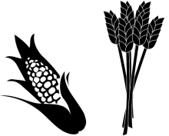
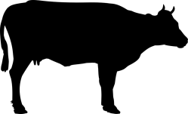
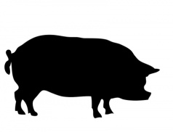
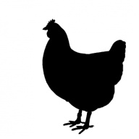
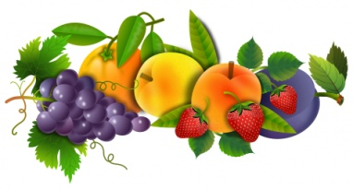
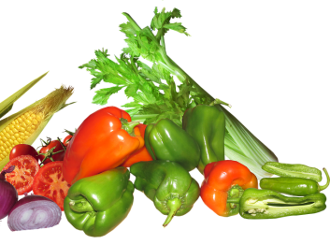
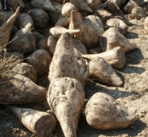

Zdroje obrázků:
[cit. 2018-05-10]. Dostupný pod licencí Public Domain a Creative Commons na WWW:
https://pixabay.com/cs/prase-zv%C3%AD%C5%99e-sele-vep%C5%99ov%C3%BD-velk%C3%A9-220277/
https://pixabay.com/cs/skot-hov%C4%9Bz%C3%AD-dobytek-kr%C3%A1va-noha-156498/
http://www.freestockphotos.biz/stockphoto/14154
https://pixabay.com/cs/ku%C5%99e-slepice-pt%C3%A1k-dr%C5%AFbe%C5%BEe-zv%C3%AD%C5%99e-937584/
https://pixabay.com/cs/plodiny-p%C5%A1enice-kuku%C5%99ice-sojov%C3%A9-1323097/
https://pixabay.com/en/sugar-beet-harvest-agriculture-crop-837809/
https://pixabay.com/cs/zelenina-potraviny-va%C5%99en%C3%AD-zdrav%C3%A1-3367605/
https://www.publicdomainpictures.net/en/view-image.php?image=204160&picture=fruit-group

